Page 1 | COLBY & BANNINGHAM PARISH COUNCIL  Christmas Newsletter December 2021 | 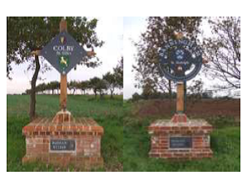

INVITATION for 22nd December
You may recall from the last Newsletter that we wanted to have an event for everyone before Christmas. So, here are the details for you to put into your diary! First, we are going ahead with a local competition to find the best Christmas light displays but there is no need to register your interest – what we will do is to send our judges around the Parish on one evening between the 17 and 20 December, so make sure your lights are up and on by then! If you live on the edge of the Parish or are at a secluded position but want to be involved then please do let us know – just so that your contribution is not missed.
The invitation is then to join us on the Village Green, just across from the Banningham Crown, from 6.30pm on Wednesday 22nd December. Mulled wine, soft drinks and mince pies will be available next to the Christmas Tree which we are setting up on the Green. The winners of the Lights competition will be announced. In addition, there will be a competition for any of our children who turn up in festive fancy dress – again, there will be prizes. It will also be an opportunity to meet with other people in the Parish in a fairly safe environment -so please do come along.
Village Hall
A great piece of news is that we have been successful in our third grant application to help our work to update the village hall – this time to purchase and install a brand-new sustainable heat pump heating system. Overall, we have now been awarded almost £33,000 to help our project! A big Thank You is due to Diane and Kevin Fields who led the work on these applications. You may also have seen activity at the Village Hall as renovations and new works are now under way and this is being organised and overseen by a group of excellent volunteers from the Parish – again Thank ~You to all of them! Work will continue through the winter period.
We hope that you and your families will remain safe and well in these trying times and if you have any further questions, then please do call the Parish Clerk on 01263 732530 or e-mail clerk@colby-banningham-pc.gov.uk .

